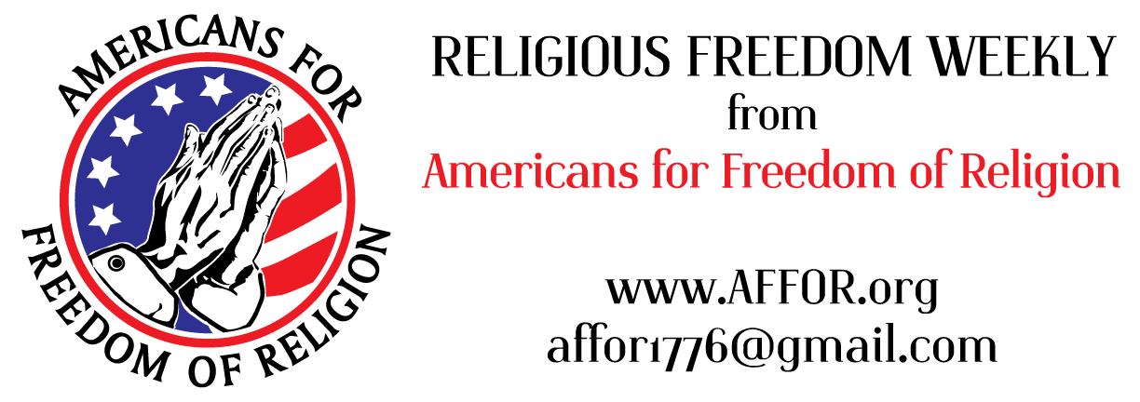

“Our Constitution was made only for a moral and religious people. It is wholly inadequate to the government of any other.” - John Adams

When a Variety of Viewpoints Is Not Acceptable…

A state Senator from Nebraska, first elected in 2016, has announced he will be switching his political affiliation because his right to maintain his pro-life views is not respected by his party.

When Mike McDonnell voted for a bill which would have banned most abortions in his state and another bill prohibiting transgender drugs and body altering surgeries for minors, his party withdrew support for him and blocked him from voting on his county’s party matters. Sen. McDonnell subsequently changed political parties.

His party issued a statement that it was not his Catholic, pro-life views they objected to, but that their actions were affirming their party’s position on these matters. The Senator believes his Catholic, pro-life views were the cause for the censures.

The treatment of Sen. McDonnell echoes a type of discrimination, a religious test for public office, shunned by our founders. The founders believed that America could preserve the extensive individual liberties of our Constitution only if the morality of each citizen could be brought into the public square of ideas, debate and policies. The morals and virtues accepted in America’s private and public spheres were to include all faiths with preference for none. To that end the founders specifically eliminated any “religious tests” from the requirements for holding public office.
“Our rulers can have authority over such natural rights only as we have submitted to them. The rights of conscience we never submitted, we could not submit. We are answerable for them to our God.” Thomas Jefferson
Read more: https://tinyurl.com/yckau9bx https://tinyurl.com/4akcs4j2 https://tinyurl.com/2axnw96f

